Code explanation
Overall flow:
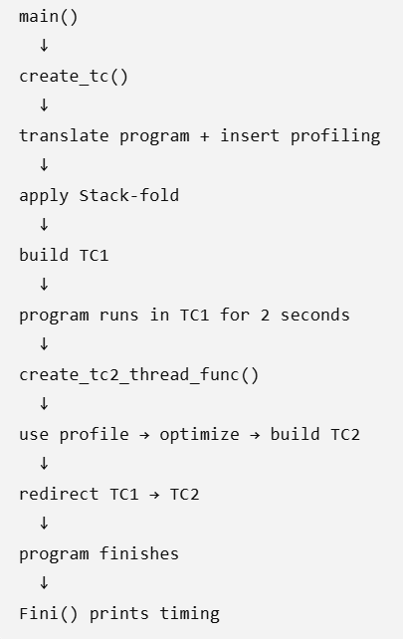
General structures:
instr_map_t *instr_map; - this struct is not TC1 and it is not TC2. TC1 and TC2 are actual executable memory containing machine-code bytes. instr_map[] is the data structure your translator uses to describe those instructions before copying them into TC memory.
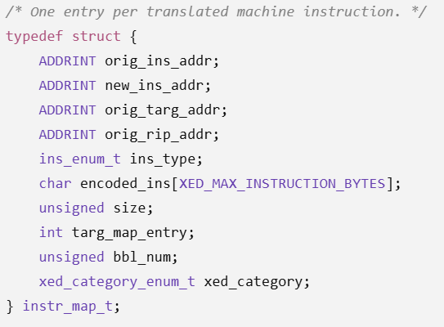
So assuming the program is:
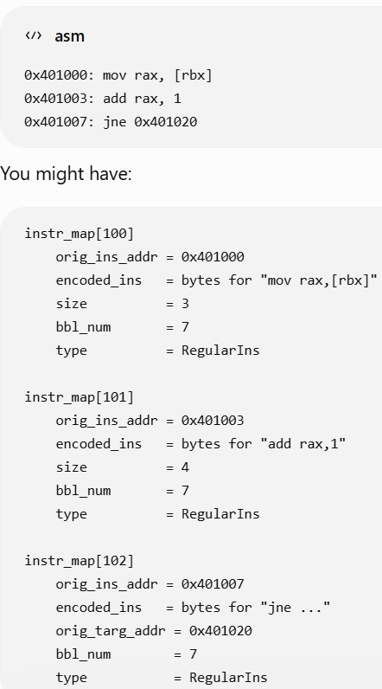
bbl_map_t *bbl_map; - structure that for each bbl contains a line that includes: how many times this BBL executed, fall-through count, where the BBL starts/ends, whether its count is measured directly or derived.
- Main – we have
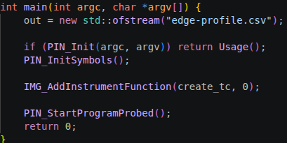

IMG_AddInstrumentFunction(create_tc, 0); - means when image is loaded (image is something like bzip2\gcc\library), call the function create_tc to look over it.

PIN_StartProgramProbed(); - tells the tool to run in probe mode.

SHORT EXPLANATION ABOUT PROBE MODE\JIT:
PROBE MODE
given some exe like bzip2\gcc(that saved at area X) and some area in memory - tc, probe mode lets me: go over the routines in exe and select which one I want-> translate these routines and copy them to tc(all that done before running the exe)->when the exe runs(in location X) and reaches a routine which was translated, probe mode writes a jmp there which jumps to tc to execute the translated code in tc.
JIT
Runs the exe in X, and when it reaches some routine it wants to translate, it translates it in runtime and copies it to some cache, and run it from there. Then, it returns to the original code.

- Create_tc() – a function that responsible for the creation of tc and the optimization done to it like ‘fold’. The main functions there are:
allocate_and_init_memory(img);
find_candidate_rtns_for_tc(img);
find_stackfold_sites();
apply_stackfold();
apply_stackfold2();
chain_all_direct_jmp_and_call_target_entries()
set_initial_estimated_new_ins_addrs_in_tc()
fix_instructions_displacements();
copy_instrs_to_tc();
commit_translated_rtns_to_tc();
spawn create_tc2_thread_func();
where the overall process is:
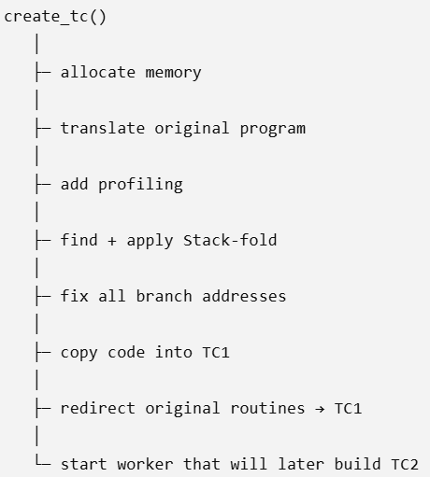
I will explain almost all functions now.

- Allocate_and_init_memory() - function reserves the memory where your translated code will live. The function had a bug – the bug was that TC/TC2 could be allocated where the Linux heap wanted to grow, causing some gccs(peak) to crash. We fixed it by placing TC/TC2 after a large safety gap above the program image, while still keeping them close enough for x86 relative branches.

- find_candidate_rtns_for_tc() - Walk through the executable routine by routine and instruction by instruction, construct instr_map/bbl_map, and insert the profiling instrumentation. Practically:
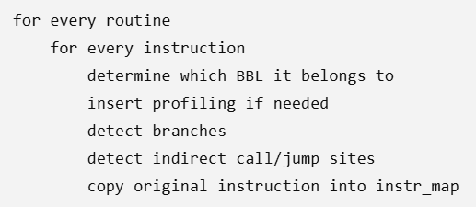

Also, sparse profiling is implemented there using: bool sparse_skip = ....
It also reserves space before indirect calls/jumps so that later TC2 can insert devirtualization guards (it reserves using a space it reserves in instr_map – 14 entries in insrt_map to be precise).

- add_profiling_instrs()
add_counter_no_save_instrs()
add_indirect_target_profile()
add_profiling_marker()
top three functions are used in find_candidate_rtns_for_tc() to generate code which will be copied to tc1: translated gcc code + profiling code. For example, for inserting counter, it will give:
save temporary registerload countercounter++store counterrestore register.
NOTE: the code is trying to optimize things so it tries to avoid some save/restores whenever safely possible – using storing in dead registers. Also, add_profiling_marker() makes sure unnecessary NOP wont be copied to tc.

- find_stackfold_sites(); - for the ‘Stack Fold’ optimization – which two types exist, this function finds candidates where to apply this optimization for each one of the types. Example for each type, type 1:
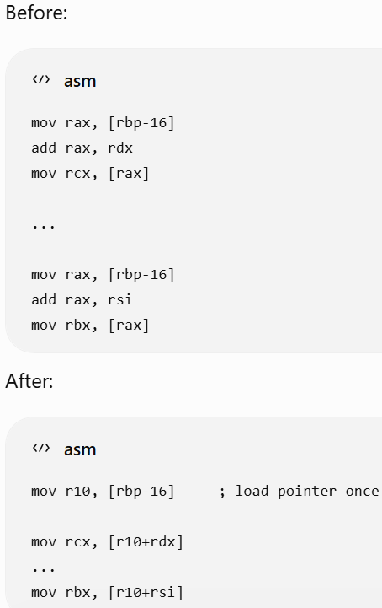
in this type, if we keep loading from a certain place in memory over and over again, cache it into register to avoid reloads.

type 2:
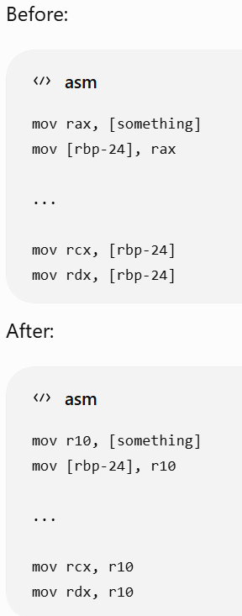
a value saved to the stack, but instead of reloading it over and over again later, also save it into register and load the register value.

After this function finishes we have two important structures: sf_sites and sf2_sites. Each one of them contains information related to the ‘fold’ optimization it related to, so later we know how to change the code according to the fold optimization. In general it contains which instructions use loaded memory value over and over again, and what register to use to write replacing instructions for them.

- apply_stackfold();
apply_stackfold2();
these functions practically rewrite the optimized code (according to ‘fold’ optimizations) to tc1.

- chain_all_direct_jmp_and_call_target_entries()
set_initial_estimated_new_ins_addrs_in_tc()
fix_instructions_displacements();
their main goal is to fix addresses of jmp\call\conditional branches\rip-relative-memory-addresses commands when moving to tc1. For example, if we had:
0x401000: jmp 0x401100
Where did 0x401100 move to?
↓
Maybe 0x700150
↓
Encode new JMP so it reaches 0x700150

- copy_instrs_to_tc(); - instr_map contains encoded machine instructions. This function physically copies those bytes into the executable TC memory.

- commit_translated_rtns_to_tc() – this function redirects (possible cause it is probe mode) execution of translated routines to be executed in tc. For example:
Before:
program calls compress()
↓
original compress()

After:
program calls compress()
↓
original routine entry
↓
Probe redirection to tc
↓
TC1 version of compress()

- PIN_SpawnInternalThread(create_tc2_thread_func, ...)
This creates another thread that will:
wait 2 seconds
↓
read profile
↓
build TC2
↓
redirect execution to TC2
Meanwhile the application itself is running in TC1.

HERE WE COVERED ALL THE CREATE_TC FUNCTIONS.

- create_tc2_thread_func() – this is another big function which is responsible for TC2 construction. Its flow is:
sleep 2 sec (profiling starts. The code runs in tc1 in areas it is optimized)
↓
copy dense counters back to bbl_map
↓
use profile
↓
apply devirtualization
↓
prepare fall-through jumps
↓
remove profiling instrumentation
↓
reorder hot code
↓
fix addresses
↓
copy final code into TC2
↓
redirect TC1 → TC2

I will explain now each stage\function.

- copy dense counters back to bbl_map – during profiling bbl_map[] contains info about the bbls int the code. It may look like this:
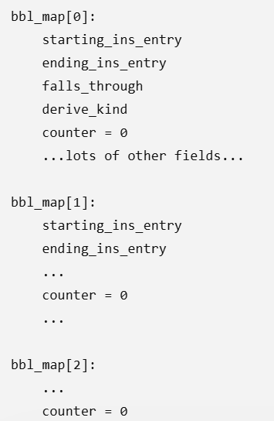
So to access each counter we have to access a big range in memory, which can be expensive in term of timings – cause during profiling we can access each bbl millions of times.
So this stage creates an array of all the counters, so they are relatively close in memory. So now we can access them faster during profiling.
Another similar idea is done for counting how many time we “fall through” the bbl. So we create an array called g_ftctr[] for it.
After profiling, we copy the arrays back to bbl_map[].

- Apply_devirt() – this function takes the info collected during profiling, and “changes instructions” in instr_map (changes lines in that structure) in a way that devirtualization is applied.
NOTE:
When TC1 was first being prepared, the code reserved entries before indirect branches (like call rax) – it reserved lines in instr_map[]. Later in tc2 construction these lines were filled with devirtualization commands.
For example:

This:
[reserved]
[reserved]
[reserved]
...
call rax

becomes:
cmp jne
direct call
jmp
fallback indirect call

- Remove instrumentation – pass instructions in inst_map[] and removes profiling instructions, so tc2 wont be built with them. In code:
if (instr_map[i].ins_type == ProfilingIns)
instr_map[i].size = 0;

- CODE REORDERING - build_and_finalize_trace_order() – using the profiling info it tries to change the bbl order so hot ones will be closer. For example:
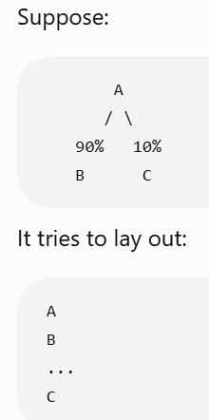
this stage can also:
It can also remove unnecessary jumps.
It can also reverse conditional branches so the hot path is the fall-through path.

- Fix code and build tc2 – done using the functions:
set_initial_estimated_new_ins_addrs_in_tc(tc2, order);
fix_instructions_displacements(order);
copy_instrs_to_tc(tc2, order);
in general, what it does is:
modified instr_map
↓
decide new TC2 addresses
↓
fix branches
↓
copy machine-code bytes into TC2

- commit_translated_rtns_to_tc2() – in inst_map[] an entry was reserved (NOP was used) at every routine head, so a jmp would be added to direct execution to tc2. At this stage, we make the NOP a jmp to tc2.
- Fini() – prints time and statistics:
TC construction time
profiling time
TC2 construction time
TC2 commit time
TC2 execution time
overall translated runtime
CPU time

